Retail Sales Data Analysis
From Raw Data to Business Insight
Final Internship Project Report
Item | Detail
Project | Data analysis of the Swynex retail orders dataset
Scope | Data acquisition, cleaning, analysis, interactive dashboard and business insight
Dataset | 626 retail orders, 12 fields, 11 Jan 2024 to 09 Dec 2026
Prepared by | [Intern name]
Organisation | Swynex
Date | 15 October 2026
Status | Final submission - supersedes the Task 1-3 working files

This report consolidates the four project tasks: sourcing and cleaning the dataset, analysing it, building an interactive dashboard, and drawing out the business insights. It also corrects two measurement defects carried through the earlier tasks.

Contents
1. Executive Summary
2. Problem Statement
3. Dataset Information
4. Data Cleaning Process
5. Analysis and Findings
6. Interactive Dashboard
7. Key Business Insights
8. Recommendations
9. Limitations and Caveats
10. Conclusion
A. Appendix - Cleaning Log and Raw Data Audit

1. Executive Summary
This project analyses 626 retail orders placed between 11 Jan 2024 and 09 Dec 2026, worth 365,723.12 in gross revenue. The work covers the full chain required of the internship: sourcing and cleaning the raw extract, analysing it, building an interactive dashboard, and translating the result into decisions. The cleaned dataset and every figure in this report are reproducible from the accompanying scripts.
Headline metric | Value
Total revenue | 365,723.12
Total orders | 626
Units sold | 2,837
Average order value | 584.22
Unique customers (by email) | 577
Distinct products / categories | 25 / 5
Order period | 11 Jan 2024 to 09 Dec 2026
Complete data rows | 523 of 626 (83.5%)
Table 1: Headline metrics from the cleaned dataset.

What the analysis found
- A broadly balanced portfolio. Revenue is spread evenly across five markets and five categories. Australia leads with 78,633.63 (21.5%), but no market holds more than a fifth of the business.
- Trading is stable, not collapsing. On a like-for-like January to August basis, 2026 revenue is -0.3% against 2025, with average order value +2.3%. The business is flat, not declining.
- Zero customer retention. 577 unique customers placed 626 orders: nobody ordered twice. There is no repeat-revenue base at all.
- A flat product mix. No product exceeds 5.8% of revenue, and the top ten products sit in a narrow band. There is no hero product to lean on.

Two corrections to the earlier tasks
1. The UK was understated. England (13,630.14) and United Kingdom (56,115.69) were two labels for one market. Merged, the UK is worth 69,745.83 and moves from rank 5 to rank 2 - the second-largest market, not the fifth. The Task 2 and Task 3 dashboards show it incorrectly.
2. The growth figures were an artefact. Whole-year totals suggest +187% growth and then -21.8% decline. Both are caused by incomplete coverage: 2024 only fills up from October, and the extract stops on 09 December 2026. A like-for-like comparison is flat.

2. Problem Statement

2.1 Context
Swynex records retail orders across several systems, and the sales extract lands in a single flat file that mixes transactional records with reporting fragments. Management wants to know where revenue actually comes from and whether trading is improving, but the raw file cannot be queried or charted safely: the header is displaced, missing values are typed as text, country names are inconsistent, and dates are stored as strings. Any figure taken straight from the raw file is therefore unreliable.

2.2 The business questions
- Market performance. Which markets generate the most revenue, and how concentrated is the business?
- Product performance. Which product categories and individual products drive sales?
- Trend. Is revenue growing, flat or declining once data coverage is accounted for?
- Payment behaviour. How do customers pay, and does the payment mix carry any operational risk?
- Geography. Where is revenue concentrated geographically below country level?
- Retention. Do customers return, or is all revenue first-time?

2.3 Why this matters
Each of the six questions is a decision input: market prioritisation, range planning, forecasting, checkout investment, logistics and marketing spend. If the underlying data is dirty, every one of those decisions inherits the error. The Task 1-3 working files demonstrate the risk concretely - the UK was reported as the fifth-largest market when it is the second, and a 21.8% revenue decline was reported that does not exist.

2.4 Objective
Produce a single, defensible view of the retail order data: a cleaned and documented dataset, a reproducible analysis, an interactive dashboard for stakeholders, and a set of business insights and recommendations that management can act on - with the limits of the data stated plainly.

3. Dataset Information

3.1 Source and structure
The project uses messy_retail_orders.csv, the raw retail order extract supplied for Task 1. The file contains 628 physical lines, of which 626 are order records. Two structural defects are immediately visible: the header row sits on line 2 beneath a blank first line, and the table carries 15 columns instead of 12 because a country-level pivot table ('Row Labels' / 'Sum of Sales') was pasted into columns N to P alongside the transactional data.
Structural observation | Finding
Physical lines in file | 628
Order records | 626
Header row | Line 2 (leading blank line)
Columns in file | 15
Columns that are real data | 12
Pasted pivot artefacts | 3 ('Row Labels', 'Sum of Sales')
Duplicate records | 0
Duplicate order IDs | 0
Order ID range | 100001 to 100750
Order IDs absent from that range | 124
Table 2: Structural audit of the raw source file.

3.2 Field dictionary
Field | Type | Description | Quality note
OrderID | Integer | Unique order identifier | 124 IDs absent from the range
CustomerName | Text | Name of the purchasing customer | 35 missing
Email | Text | Customer contact address | 49 missing; all present values valid
ProductCategory | Text | Product grouping (5 values) | Clean
ProductName | Text | Item sold (25 products) | Clean
Quantity | Integer | Units per order (1 to 8) | Clean
UnitPrice | Decimal | Price per unit | Clean
Sales | Decimal | Order value = Quantity x UnitPrice | Reconciles on all 626 rows
OrderDate | Text to date | Date of order | Stored as dd/mm/yy text; 374 rows prove day-first
Shippingcity | Text | Destination city | 26 missing; 586 distinct
Country | Text | Destination market | 52 missing; England and UK duplicated
PaymentMethod | Text | Checkout method | 36 missing
Table 3: Field-level dictionary and the quality issue attached to each field.

3.3 Coverage and period
Orders span 11 Jan 2024 to 09 Dec 2026, covering parts of three calendar years. Coverage is not even across that window, which turns out to be the single most important fact in the whole analysis and is examined in section 5.3. In short, 2024 is barely populated before October, 2025 is complete and evenly distributed, and 2026 is truncated after September.
Currency: the source file states no currency, so all monetary values in this report are presented as raw units without a symbol. The Task 2 workbook displayed them with a rupee symbol, which was an unverified assumption and has not been carried forward.

4. Data Cleaning Process
Cleaning followed one rule: correct what is provably wrong, label what is merely missing, and never invent a value. Records were retained wherever possible so that the size of the business is not silently reduced by the cleaning itself. Every step below is implemented in the accompanying script and can be re-run against the original file to reproduce the cleaned dataset exactly.

4.1 The problems found
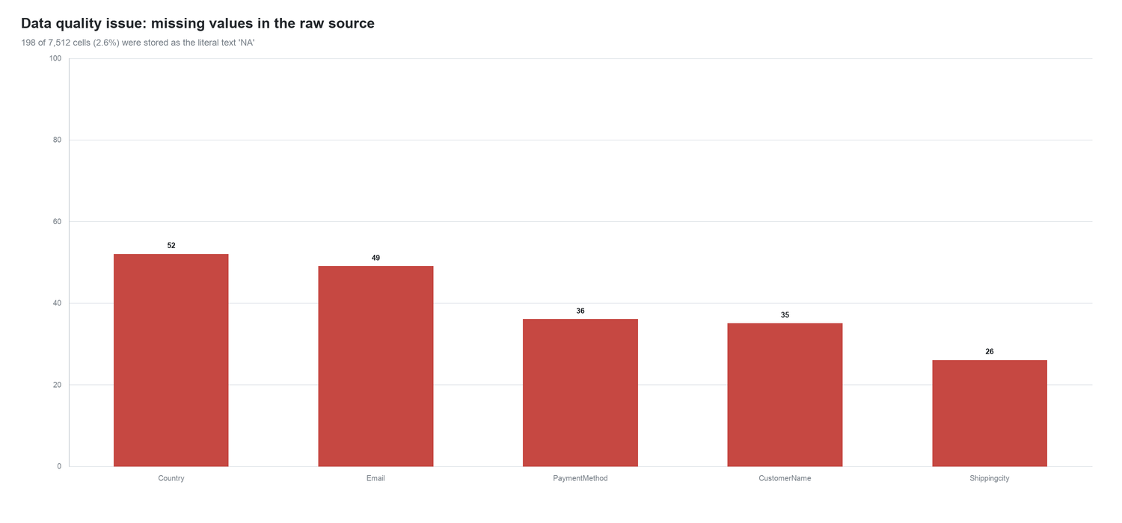
Figure 1: Missing values in the raw extract. All 198 gaps were stored as the literal text 'NA', which a chart reads as a real category rather than as absent data.
Beyond the missing values, the raw file carried four further defects: a displaced header, three pivot-table columns pasted into the data region, inconsistent country labels, and dates stored as text. Critically, two of these defects do not raise an error - they simply produce a wrong answer, which is why they survived into the Task 2 dashboard.

4.2 The cleaning steps
# | Action | Issue addressed | Result
1 | Promoted header row | Source file began with a blank line; the true header was on row 2. | 626 data rows, 15 columns
2 | Removed pasted pivot-table columns | Columns N-P held an unrelated country-level pivot ('Row Labels' / 'Sum of Sales'). | Reduced to the 12 core columns
3 | Standardised the 'NA' missing marker | Missing values were stored as the literal text 'NA' across 5 columns. | 198 cells converted to true nulls
4 | Standardised country names | England and United Kingdom both appeared for one market; U.S.A used for USA. | 139 labels remapped; 52 blanks labelled 'Unknown'
5 | Labelled missing payment methods | Blank payment methods would silently vanish from a share-of-total chart. | 36 rows labelled 'Unknown' and retained
6 | Parsed dates and derived fields | Dates were stored as dd/mm/yy text, unusable for time-series grouping. | 626 parsed, 0 unparseable; Year/Month/Quarter added
7 | Validated the Sales measure | Sales is a derived field (Quantity x UnitPrice), not an independent input. | 626/626 rows reconcile exactly
Table 4: The ten cleaning steps applied to the raw extract.

4.3 The country-name defect and its impact
'England' and 'United Kingdom' both appeared as destination markets, splitting one market across two rows: 13,630.14 recorded under England and 56,115.69 under United Kingdom. The same defect appeared as 'U.S.A' instead of 'USA'. Merging them produces a UK total of 69,745.83, which is 19.1% of revenue and the second-largest market in the business, ahead of India. In the uncorrected view the UK ranked 5th.
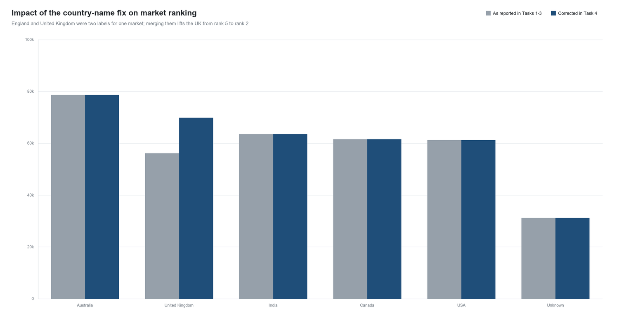
Figure 2: The country fix. Only the United Kingdom changes, but the change moves it above India and Canada and alters the market priority list.

4.4 What was deliberately not done
- No silent deletion. Missing countries and payment methods were labelled 'Unknown' rather than dropped, because dropping them would remove a real 8.5% of revenue from the country totals and hide the size of the data gap.
- No imputation. No customer name, city or country was guessed from another field. The residual gaps are small enough to disclose rather than paper over.
- No invented records. Order IDs absent from the sequence were left absent. It cannot be determined whether they were cancelled, never issued or simply filtered out, so they were not fabricated.

4.5 Residual gaps after cleaning
Field | Missing cells | Share of rows
Email | 49 | 7.8%
CustomerName | 35 | 5.6%
Shippingcity | 26 | 4.2%
Total | 110 | 1.46% of all cells
Table 5: Gaps remaining in the cleaned dataset. These are retained and disclosed, not filled.

4.6 Cleaning output
The cleaning stage produces two files: a machine-readable CSV and a workbook that documents the work. The workbook carries the cleaned records, the ten-step cleaning log, the raw-data audit and a sheet for each analysis view.
Deliverable file | Contents
cleaned_retail_orders.csv | 626 cleaned records, 12 original fields plus Year, Month, Quarter
cleaned_retail_orders.xlsx | Cleaned Data, Cleaning Log, Raw Audit, Sales by Country, Sales by Category, Monthly Trend, Payment Methods, Top Cities
Table 6: Cleaning outputs produced for this project.

5. Analysis and Findings

5.1 Revenue by market
Revenue is distributed remarkably evenly across markets. Australia leads with 78,633.63 (21.5%), followed by the corrected United Kingdom at 69,745.83 (19.1%). The top five markets each hold between 16.7% and 21.5% of revenue, a spread of under five percentage points. Average order value is similarly tight, from 532.20 in the USA to 655.28 in Australia.
Market | Revenue | Orders | Avg order value | Share
Australia | 78,633.63 | 120 | 655.28 | 21.5%
United Kingdom | 69,745.83 | 116 | 601.26 | 19.1%
India | 63,504.97 | 119 | 533.66 | 17.4%
Canada | 61,491.73 | 104 | 591.27 | 16.8%
USA | 61,202.73 | 115 | 532.20 | 16.7%
Unknown | 31,144.23 | 52 | 598.93 | 8.5%
Table 7: Revenue by market after the country-name correction.
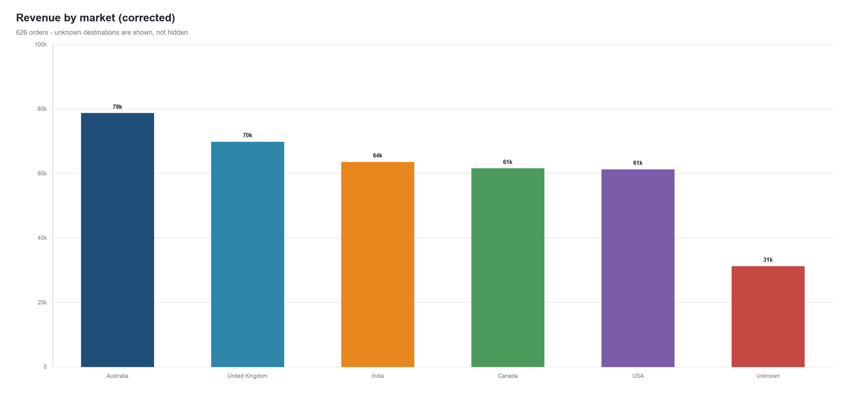
Figure 3: Revenue by market. 'Unknown' represents the 52 orders with no destination recorded and is shown rather than hidden.

5.2 Revenue by category
All five categories fall inside a narrow band from Sports at 60,936.28 (16.7%) to Home & Kitchen at 77,325.14 (21.1%). The three middle categories are separated by barely one percentage point. Beauty achieves the highest average order value at 615.56 despite ranking fourth on total revenue, suggesting a slightly more premium basket rather than a larger one.
Category | Revenue | Orders | Units | Avg order value | Share
Home & Kitchen | 77,325.14 | 132 | 577 | 585.80 | 21.1%
Apparel | 76,419.63 | 134 | 600 | 570.30 | 20.9%
Electronics | 75,943.54 | 129 | 587 | 588.71 | 20.8%
Beauty | 75,098.53 | 122 | 558 | 615.56 | 20.5%
Sports | 60,936.28 | 109 | 515 | 559.05 | 16.7%
Table 8: Revenue by product category.
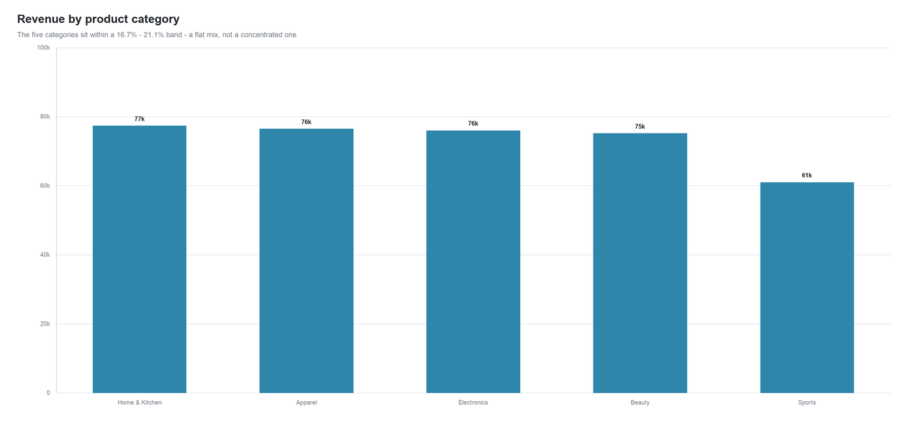
Figure 4: Revenue by category. The flat profile means no single category can be credibly promoted as the growth engine.

5.3 Trading trend and the coverage problem
This is the most important finding in the analysis, and it contradicts the picture presented by the Task 2 and Task 3 dashboards. Taken at face value the whole-year totals show revenue rising +187% in 2025 and then falling -21.8% in 2026. Both movements are artefacts of incomplete data capture rather than changes in trading.
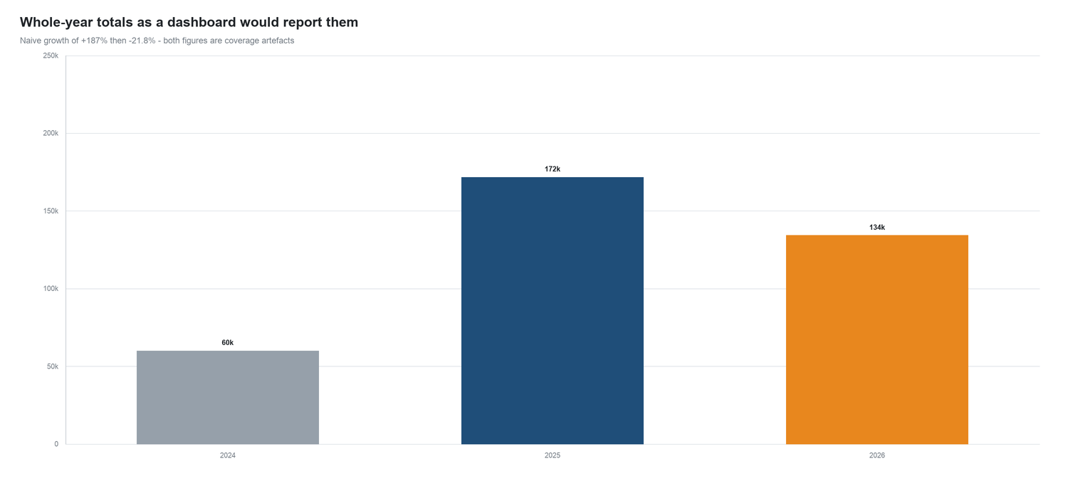
Figure 5: Whole-year totals as a dashboard would report them. The apparent surge and collapse are driven by data coverage, not by demand.
The monthly order counts expose the problem. In 2024 only 29 of 100 orders fall between January and September: the extract effectively begins in October. In 2026 the flow stops after September, with October, November and December collapsing to 23 orders in total against 78 in the equivalent 2025 quarter, because extraction ends on 09 Dec 2026. 2025 is the only year that is complete and evenly distributed, at 24.8 orders per month.
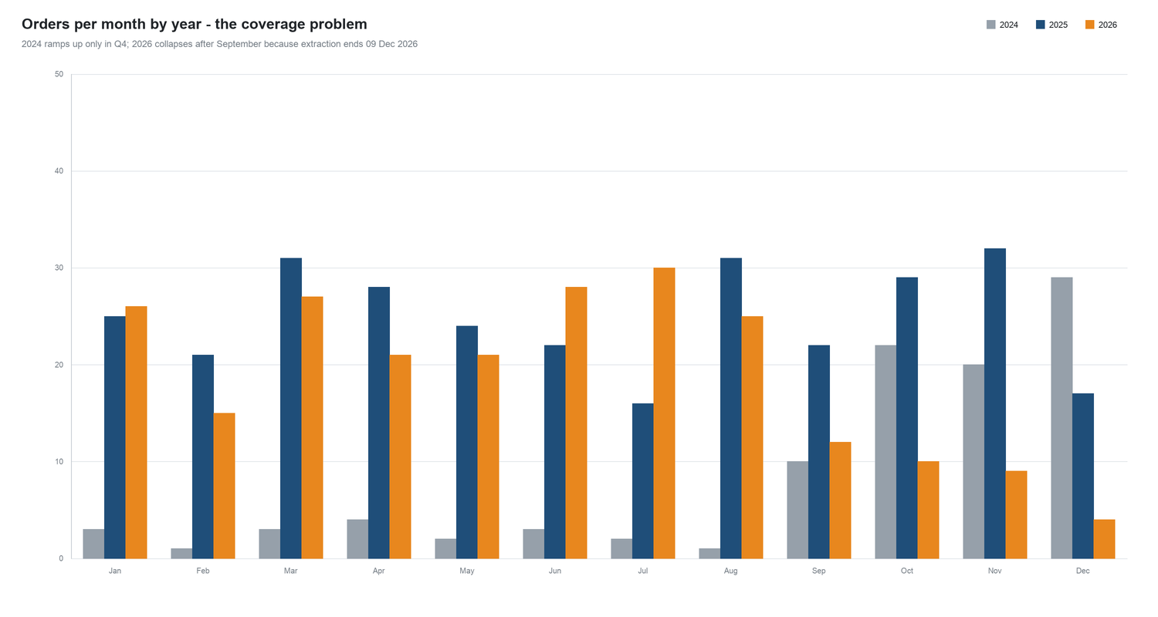
Figure 6: Orders per month by year. 2024 ramps up late; 2026 falls away after September.
Restricting the comparison to the two evenly captured years and the months they genuinely share gives a very different answer. For January to August, 2025 produced 115,012.08 from 198 orders and 2026 produced 114,713.63 from 193 orders: a change of -0.3% in revenue, while average order value actually rose +2.3% from 580.87 to 594.37. The business is flat, and slightly healthier on basket value.
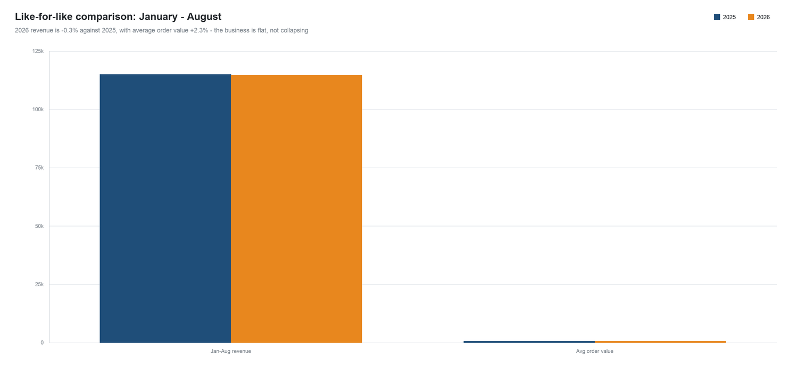
Figure 7: Like-for-like comparison for January to August. Revenue is flat and average order value is marginally up.
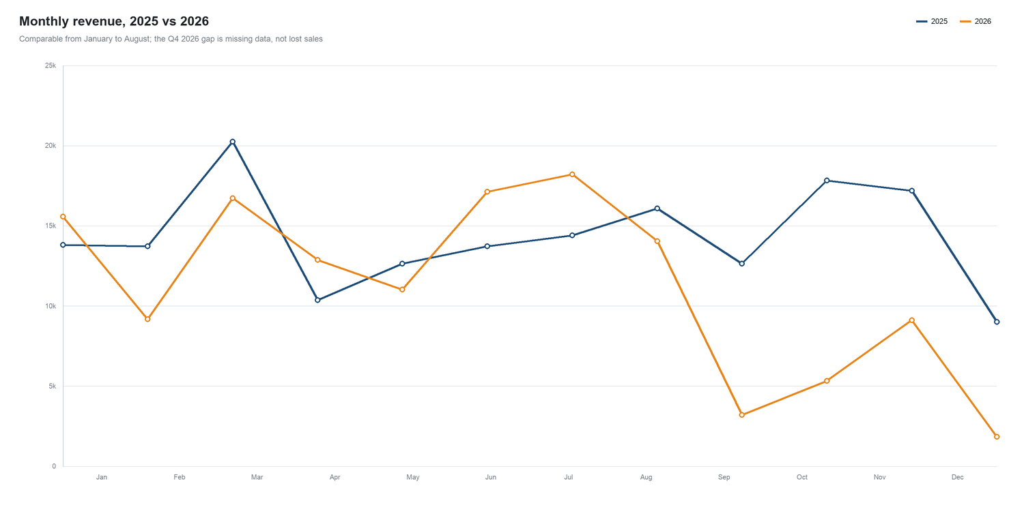
Figure 8: Monthly revenue, 2025 against 2026. The two years track each other closely until the 2026 extract runs out.
Comparison | 2025 | 2026 | Change
Jan-Aug revenue | 115,012.08 | 114,713.63 | -0.3%
Jan-Aug orders | 198 | 193 | -2.5%
Jan-Aug average order value | 580.87 | 594.37 | +2.3%
Whole-year revenue (misleading) | 171,645.44 | 134,182.84 | -21.8%
Table 9: Like-for-like comparison against the misleading whole-year view.

5.4 Payment methods
Credit card is the leading method with 118,947.29 (31.9% of orders), but the mix is broad: cash on delivery still carries 20.3% of orders and each of the five named methods holds at least 12.8%. There is no single point of failure, though cash on delivery at a fifth of orders is a meaningful operational and reconciliation load.
Payment method | Revenue | Orders | Share of orders
Credit Card | 118,947.29 | 200 | 31.9%
Cash On Delivery | 80,856.79 | 127 | 20.3%
Upi | 56,793.75 | 96 | 15.3%
Net Banking | 46,834.90 | 87 | 13.9%
Debit Card | 45,114.14 | 80 | 12.8%
Unknown | 17,176.25 | 36 | 5.8%
Table 10: Revenue and order share by payment method.
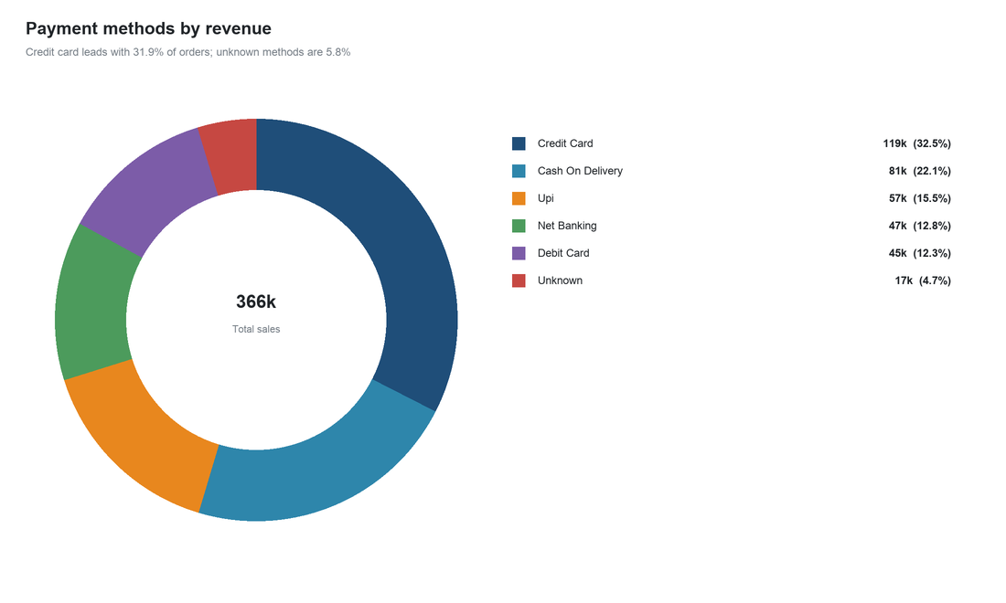
Figure 9: Payment methods by revenue. Unknown methods account for 4.7% of revenue.

5.5 Product concentration
Across 25 products there is no standout performer. The leading product, Wool Sweater, generates 21,302.42, or 5.8% of total revenue. The top ten products are separated by only about six thousand units of revenue, which indicates a deliberately broad assortment rather than a hit-driven one.
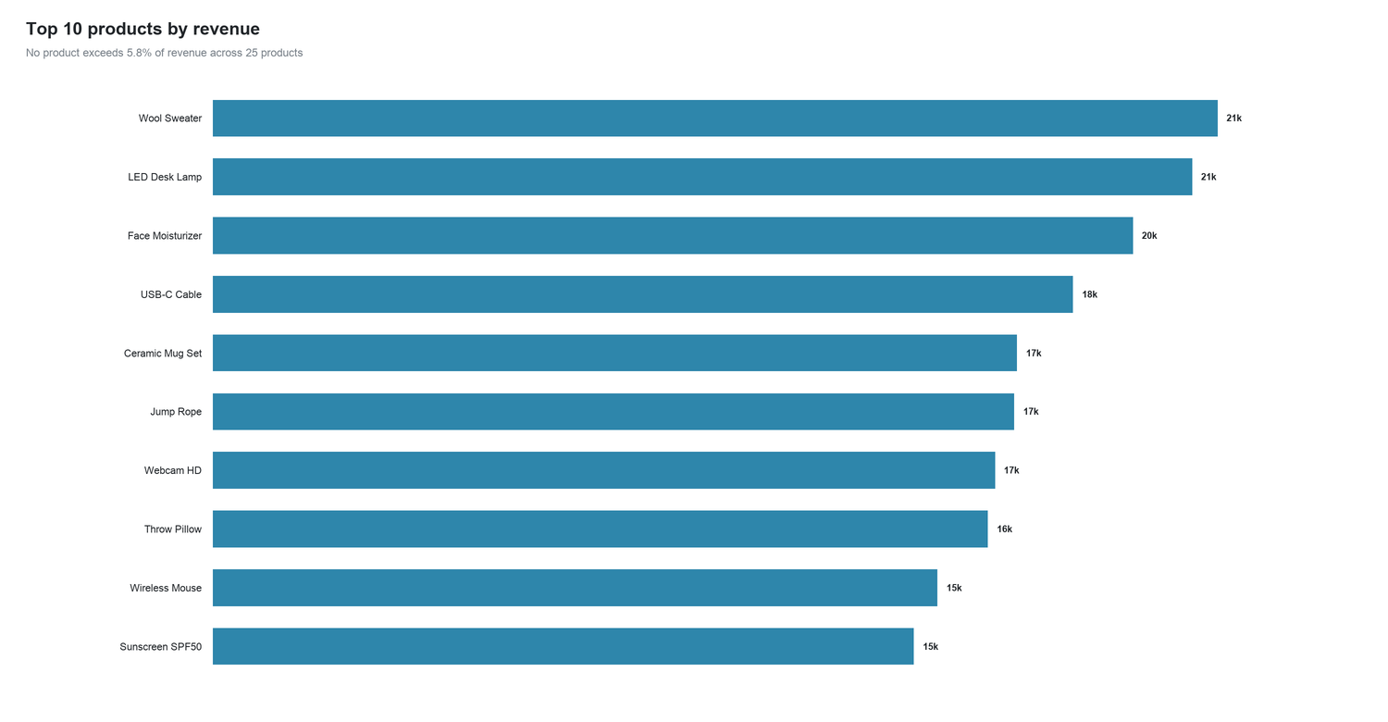
Figure 10: Top ten products by revenue. The shallowness of the ranking is the finding: no product is carrying the business.

5.6 Geographic fragmentation
Below country level the data is too fragmented to support decisions. Orders ship to 586 distinct cities, and the ten largest together account for just 5.9% of revenue. The single largest city, Michaelview, represents 3,106.39 from only 2 orders. City-level reporting on this dataset measures individual orders, not market structure.
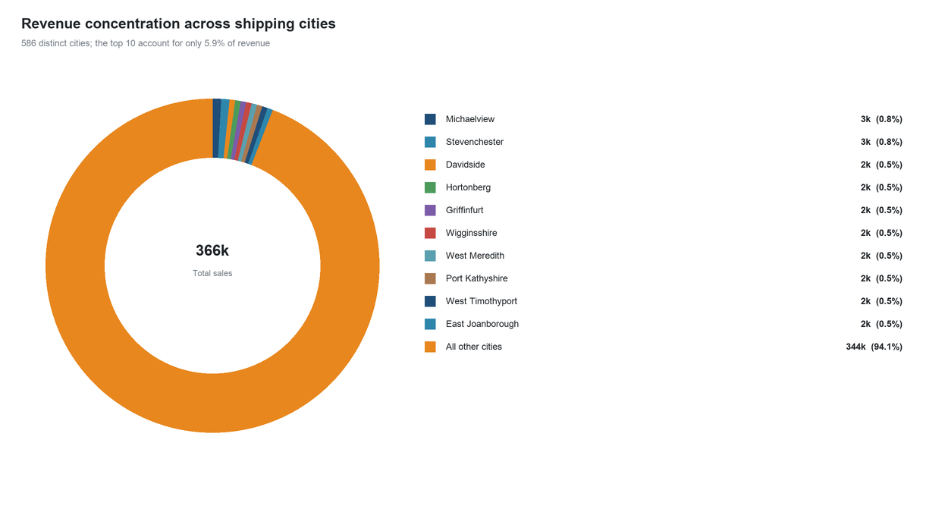
Figure 11: Revenue concentration across shipping cities. Almost all revenue sits in the long tail.

5.7 Customer behaviour
The dataset contains 577 unique customer email addresses against 626 orders, and not one customer appears twice. Every order in the file is a first purchase. Whatever the cause, the analytical consequence is the same: there is no repeat-purchase behaviour to measure, no retention rate to track, and no customer lifetime value that can be estimated from this data.
Important caveat. A dataset in which 626 orders are placed by 626 different customers is statistically implausible for a real retailer. Combined with example.com email domains and generated city names, this strongly suggests the extract is synthetic or anonymised test data. The methodology in this report stands, but the commercial conclusions should be validated against production data before any decision is taken.

6. Interactive Dashboard

6.1 What was built
Task 3 delivered an interactive dashboard as a Tableau workbook (Dashboard.twb) built on the cleaned dataset. The dashboard is filter-driven: a Year selector and a Country selector drive every view on the canvas simultaneously, so a stakeholder can isolate a market and a period and see the whole picture update.
Dashboard element | Type | Business question it answers
Monthly Sales Trend | Line chart | How is revenue moving through the year?
Sales By Countries | Column chart | Which markets are largest?
Categories Sales | Bar chart | Which product categories perform best?
TOP 5 Cities By Sales | Bar chart | Where are the biggest cities?
Payment methods | Pie chart | How do customers prefer to pay?
Year / Country filters | Interactive selectors | Slice the whole view by period and market
KPI panels | Summary tables | Country, month, product and payment totals with a grand total
Table 11: Components of the Task 3 interactive dashboard.
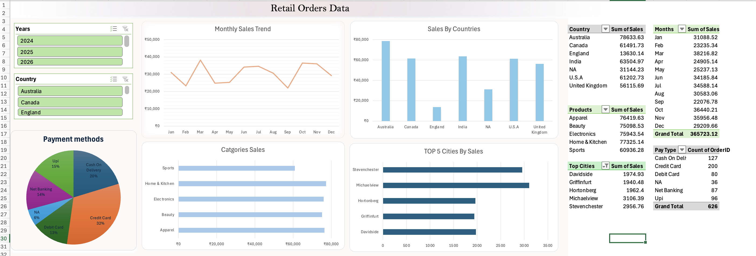
Figure 12: The interactive dashboard as delivered in Task 3, showing the grand total of 365,723.12 across 626 orders.

6.2 Known defects in the delivered dashboard
Two measurement errors visible in this dashboard are corrected in this report. Both come from the data rather than from the visual design, so they are fixed by cleaning the source rather than by rebuilding the dashboard.
- Split UK market. 'England' and 'United Kingdom' appear as separate bars, splitting one market in two and understating the UK by 13,630.14. After correction the UK is the second-largest market, not the fifth.
- Missing data presented as a category. 'NA' is charted as though it were a country and ranked as a real market in the payment pie and country bar. It is actually 52 orders of missing data worth 31,144.23, and it is better labelled as Unknown.
- A year filter that misleads. The Year filter invites a year-over-year comparison that the data cannot support, because 2024 and 2026 are only partially covered. Selecting 2026 shows a decline that is really a truncated extract.
- City panel is noise. The top-five-cities panel looks meaningful but rests on individual orders: the leading city records two orders. It should be replaced with market-level reporting.

6.3 Using the dashboard
For a corrected reading of the business, use the dashboard to explore market and category structure, which are robust, and treat any single-year comparison with caution. The like-for-like figures in section 5.3 of this report are the defensible basis for trend statements.

7. Key Business Insights

Insight 1 - Trading is flat, and the reported decline is not real
Evidence: Whole-year totals imply +187% then -21.8%. Correcting for coverage, January to August revenue moves -0.3% and average order value rises +2.3%.
Implication: Do not commission a recovery plan for a decline that exists only in the extract. Fix the extraction window first.

Insight 2 - The United Kingdom is the second-largest market, not the fifth
Evidence: Merging the duplicated labels produces 69,745.83, 19.1% of revenue, moving the UK from rank 5 to rank 2 at the expense of India and Canada.
Implication: Market prioritisation and any UK-specific resourcing decision taken from the earlier dashboard were based on an understated figure.

Insight 3 - There is no customer retention to speak of
Evidence: 577 customers, 626 orders, zero repeat purchases. All revenue is first-time revenue.
Implication: Growth depends entirely on continued acquisition. There is no installed base to defend, and no loyalty metric can be computed until customers are identified properly.

Insight 4 - The product mix is flat, so there is no hero product to scale
Evidence: All five categories sit between 16.7% and 21.1% of revenue, and the top product takes just 5.8%.
Implication: Range decisions should be made on margin and availability rather than on chasing a breakout product that the data does not contain.

Insight 5 - Revenue moves with order count, not basket size
Evidence: Average order value is stable at 584.22 overall and moved only +2.3% year on year, while monthly order counts ranged from 16 to 32.
Implication: The growth lever is demand generation and conversion, not upselling or price increases.

Insight 6 - Geographic reporting below country level is not actionable
Evidence: 586 cities, top ten share 5.9%, largest city from 2 orders.
Implication: Drop the city panel from the dashboard and reinvest that attention in market-level and category-level reporting.

Insight 7 - Payment is broad-based with credit card leading
Evidence: Credit card takes 31.9% of orders, cash on delivery 20.3%, and every named method holds at least 12.8%.
Implication: No single payment method is a systemic risk, but cash on delivery at a fifth of orders is a material reconciliation and fulfilment cost worth quantifying.

Insight 8 - One in twelve revenue units cannot be attributed to a market
Evidence: 52 orders worth 31,144.23, or 8.5% of revenue, have no country recorded.
Implication: This is the largest correctable gap in the dataset and directly weakens every geographic conclusion.

8. Recommendations
# | Recommendation | Rationale | Priority
1 | Enforce country as a controlled list at the point of capture | Recovers attribution for the 8.5% of revenue currently recorded as Unknown and prevents a repeat of the England / United Kingdom split | High
2 | Introduce a customer identifier and instrument repeat purchase | Retention currently cannot be measured and appears to be zero; without a customer key there is no way to confirm or manage it | High
3 | Standardise the reporting window and always compare like for like | Partial years produced a false decline of 21.8%; comparisons must use complete, evenly covered periods | High
4 | Replace the city panel with market and category reporting | 586 cities with a 5.9% top-ten share cannot support a decision | Medium
5 | Adopt the corrected market ranking in all onward reporting | The UK moves from fifth to second, which changes market prioritisation | Medium
6 | Add automated data-quality checks to the pipeline | Null counts, allowed-value lists and row-count checks would have caught both defects in this report at the time of loading | Medium
7 | Quantify the cost of cash on delivery and review the threshold for offering it | Cash on delivery is 20.3% of orders and carries a reconciliation and returns burden | Medium
8 | Validate the findings against production data before acting | The dataset has the hallmarks of synthetic test data, so the commercial conclusions need confirmation | High
Table 12: Recommendations, rationale and priority.

9. Limitations and Caveats
Limitation | Effect on the analysis
The dataset appears to be synthetic (example.com emails, generated city names, 626 orders from 626 distinct customers) | Methodology is sound and transferable, but the commercial findings should be confirmed on live data
No currency is specified in the source | Monetary values are reported as raw units without a symbol
No cost, margin or discount fields exist | The analysis covers revenue only; profitability cannot be assessed
No customer identifier beyond email, and 49 orders have no email | Customer counts and retention are approximate and possibly understated
2024 is only populated from October and 2026 stops on 09 December | Whole-year trend comparison is invalid; only like-for-like windows are used
124 order IDs are absent from the sequence 100001 to 100750 | It is unknown whether they were cancelled, never issued or filtered; the true order count may be higher
110 cells (1.46% of all cells) remain missing after cleaning | Affects customer, city and country detail; retained rather than imputed
No order status, returns or cancellation data | Gross revenue may overstate realised revenue
Table 13: Limitations that bound how far these conclusions can be taken.

10. Conclusion
The project set out to turn a raw retail extract into decision-ready insight, and it does. 626 orders worth 365,723.12 were cleaned, validated and analysed, and the analysis is reproducible from the accompanying scripts.
The substantive conclusion is that Swynex's retail business is broadly balanced and stable. Five markets and five categories each contribute a similar share of revenue; no product, category or customer dominates; and, once data coverage is accounted for, trading between 2025 and 2026 is flat with a modestly improving basket value. The two apparent dramas in the earlier dashboard - a collapsing 2026 and a fifth-placed UK - were both measurement errors rather than business events.
The most valuable outcome of the cleaning work is therefore not any single number but the discovery that two silent data defects had been producing confident, wrong answers. Country labels split a market in two, and a truncated extract manufactured a 21.8% decline. Neither raised an error. This is the argument for the data-quality controls recommended in section 8: on this dataset, the expensive mistakes were the ones that looked like clean results.
The clearest genuine gap in the business picture is customer retention. With every order in the file a first purchase, there is no repeat revenue to build on, and no way to measure loyalty until customers can be identified. That, together with fixing the 8.5% of unattributed revenue, is where the next iteration of this work should begin.

Appendix - Cleaning Log and Raw Data Audit

A.1 Raw data audit
Check | Result
Source file | messy_retail_orders.csv
Physical lines | 628
Header row | Line 2 (leading blank line present: True)
Columns in file / real data columns | 15 / 12
Records | 626
Missing cells in raw file | 198 (all stored as the text 'NA')
Date format | dd/mm/yy (day-first) - consistent, no ambiguity conflict
Rows proving day-first dates | 374 (day value above 12)
Rows contradicting day-first dates | 0
Sales = Quantity x UnitPrice mismatches | 0
Invalid non-empty email addresses | 0
Duplicate records | 0
Duplicate order IDs | 0
Order ID range | 100001 to 100750
Order IDs absent from range | 124
Table 14: Complete raw-data audit. The ten cleaning steps are listed in Table 4.

A.2 Analysis output tables
Year | Revenue | Orders | Avg orders per month | Coverage verdict
2024 | 59,894.84 | 100 | 8.3 | Ramp-up only
2025 | 171,645.44 | 298 | 24.8 | Complete and evenly distributed (~25 orders/month)
2026 | 134,182.84 | 228 | 19.0 | Truncated
Table 15: Annual totals with the coverage caveat attached.
Month | 2024 | 2025 | 2026 | All years
Jan | 1,716 | 13,807 | 15,566 | 31,089
Feb | 342 | 13,727 | 9,166 | 23,235
Mar | 1,245 | 20,259 | 16,712 | 38,217
Apr | 1,657 | 10,373 | 12,876 | 24,905
May | 1,571 | 12,645 | 11,022 | 25,237
Jun | 3,344 | 13,724 | 17,118 | 34,186
Jul | 1,982 | 14,393 | 18,213 | 34,588
Aug | 457 | 16,086 | 14,041 | 30,583
Sep | 6,250 | 12,635 | 3,192 | 22,077
Oct | 13,292 | 17,819 | 5,329 | 36,440
Nov | 9,667 | 17,182 | 9,108 | 35,956
Dec | 18,371 | 8,997 | 1,841 | 29,210
Table 16: Revenue by month and year. Read alongside the coverage matrix in Figure 6.

